

**CSE2007 : Database Management Systems**

**Name :** Gudi Varaprasad

**Reg. No. :** 19BCE7048

School of Computer Science and Engineering

**Lab Slot :** L45 + L46

**Date :** 04 – 03 – 2021

**Submitted to :** Ms. Dhanavanthini madam

**Single row and Group Function Queries**

**Numeric Functions**

**1. abs(n)**

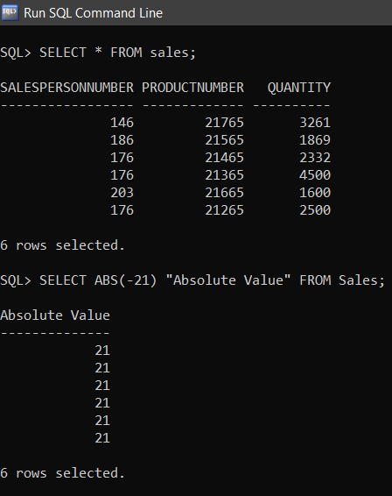

**2. ceil(n)**

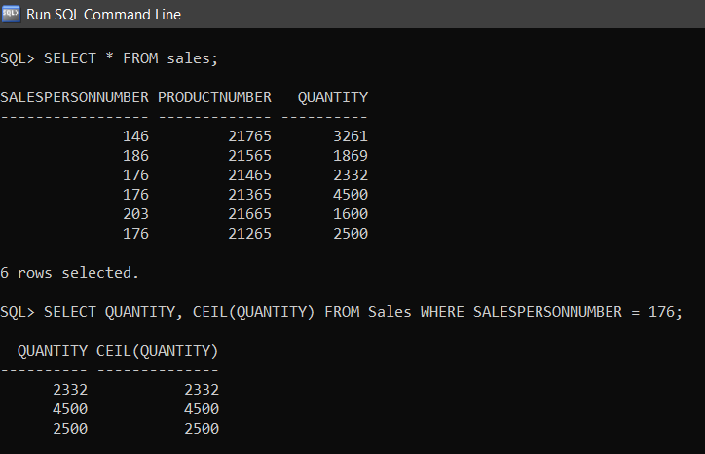

**3. cos(n)**

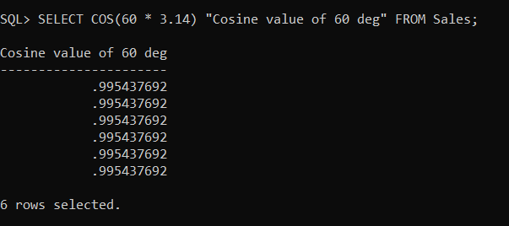

**4. cosh(n)**

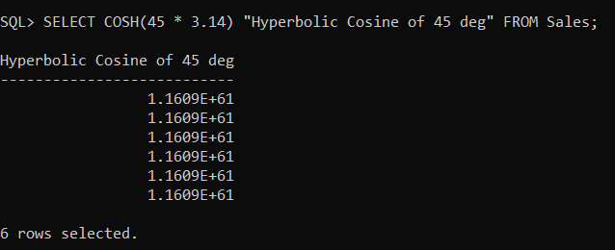

**5. exp(n)**

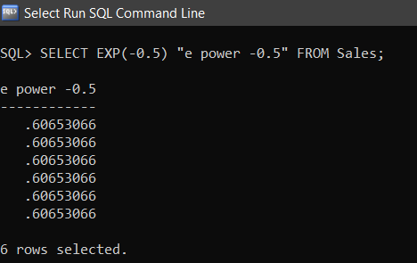

**6. floor(n)**

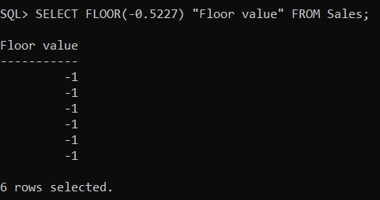

**7. power(m,n)**

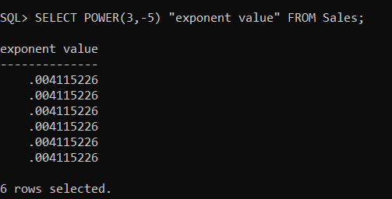

**8. mod(m,n)**

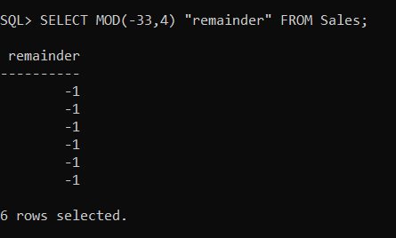

**Created a Table for performing operations :**

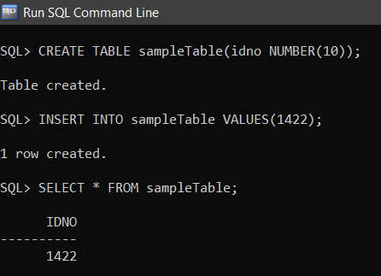

**9. round(m,n)**

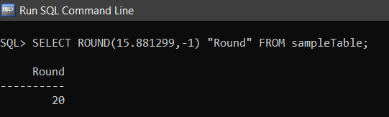

**10. trunc (m,n)**

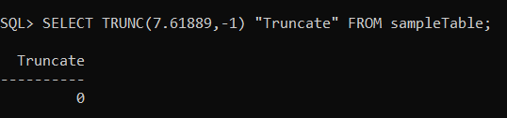

**11. sqrt (n)**

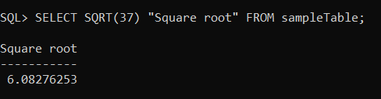

**Character Functions**

**1. initcap(char)**

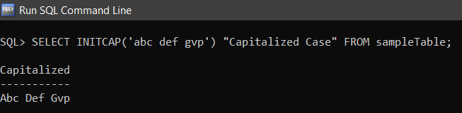

**2. lower (char)**

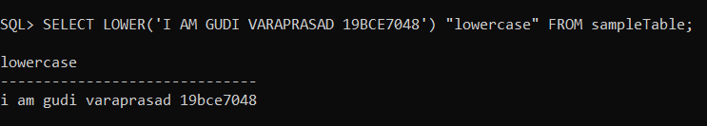

**3.** **upper (char)**

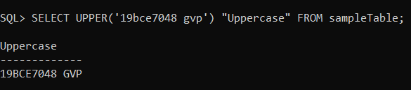

**4. ltrim ( char, set)**

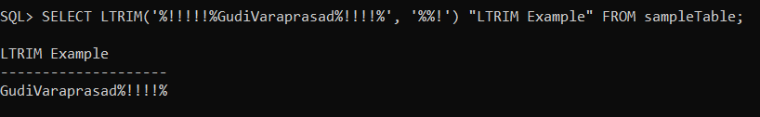

**5. rtrim (char, set)**

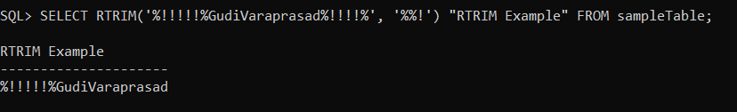

**6. translate(char, from, to)**

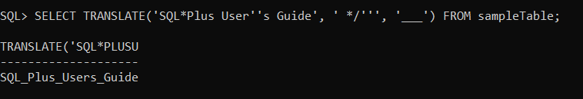

**7. replace(char, search string, replace string)**

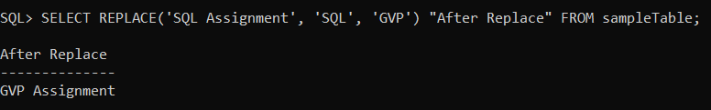

**8. substr(char, m , n)**

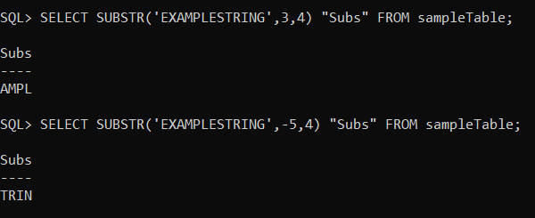

**9. lpad(char, length, special char)**

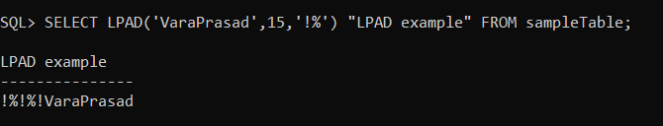

**10. rpad(char, length, special char)**

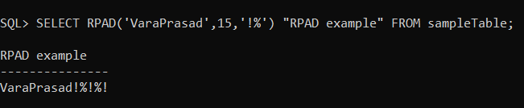

**11. chr(number)**

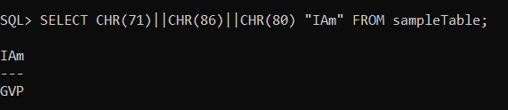

**12. length(char)**

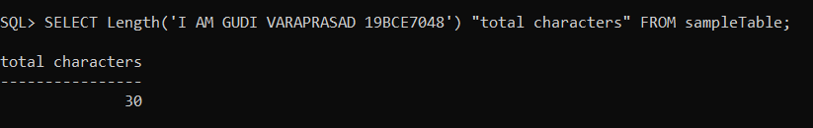

**13. decode(column name, col value, replace value)**

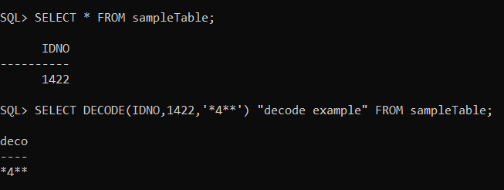

**Date functions**

**1. add_months(date,no. of months)**

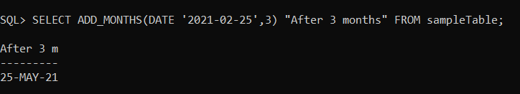

**2. last_day(date)**

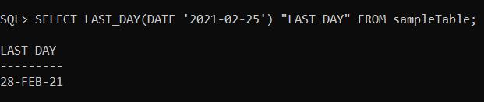

**3. months_between(date1,date2)**

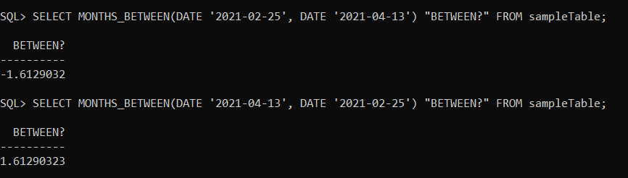

**4. round(date )**

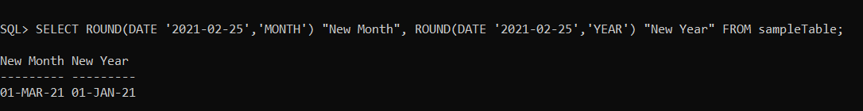

**5. next_day(date, day)**

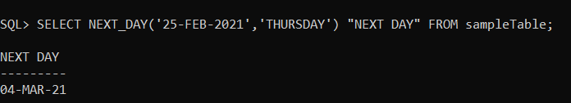

**6. trunc(date, [format] )**

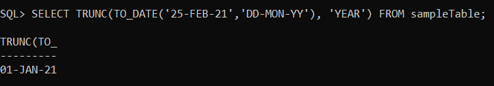

**7. greatest(date1, date2,…)**

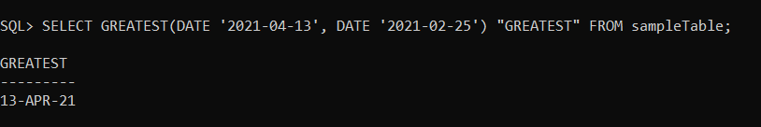

**8. new_time(date, ‘this’, ‘other’)**

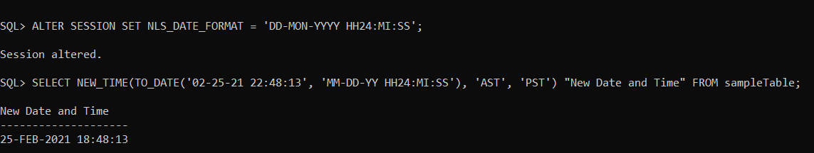

**Conversion functions**

**1. to_char(date, format)**

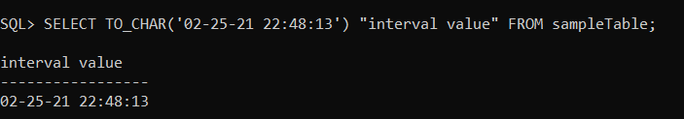

**2. to_date(char,format)**



**3. to_number(char)**

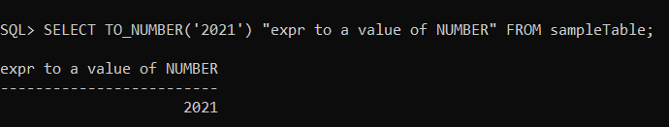

**V. Miscellaneous functions :**

**1. uid**

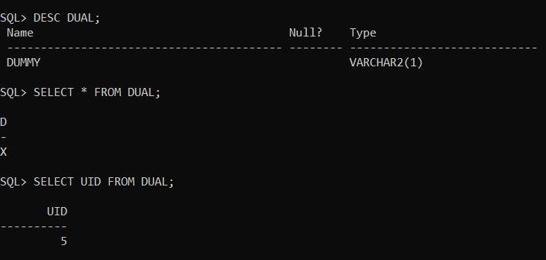

**2. user**

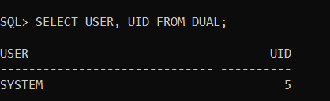

**3. nvl (column name, new value)**

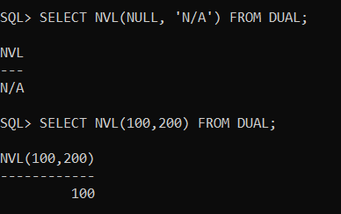

**4. vsize(value)**

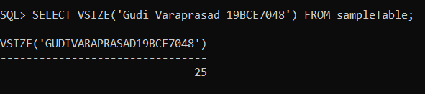

**Group functions**

**1.** **count (*)**

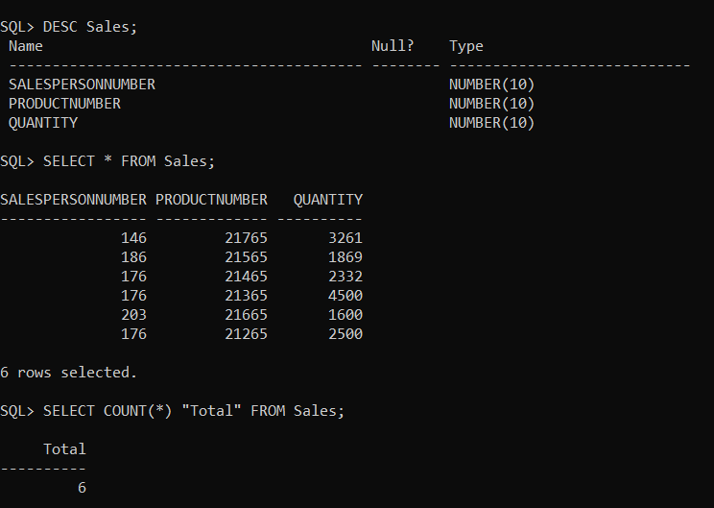

**2.count (column name)**

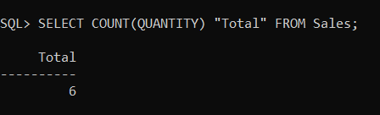

**3. count (distinct column name)**

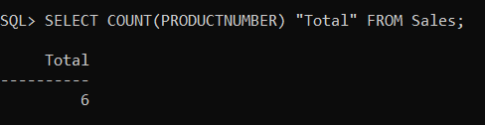

**4. min (column name)**

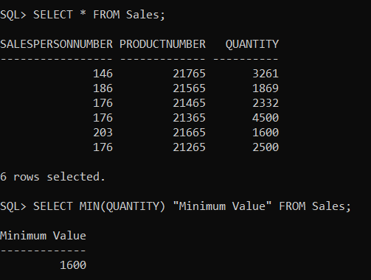

**5. max (column name)**

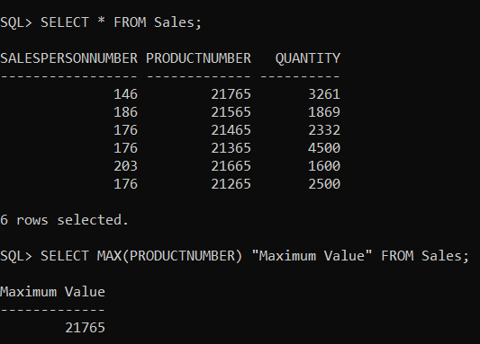

**6. avg (column name)**

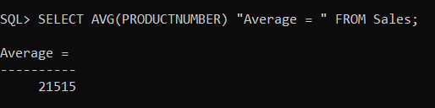

**7. sum (column name)**

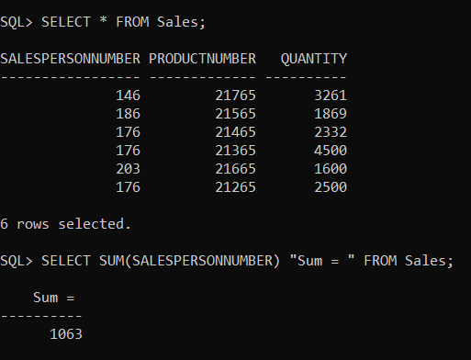

**8. stddev_pop(column name)**

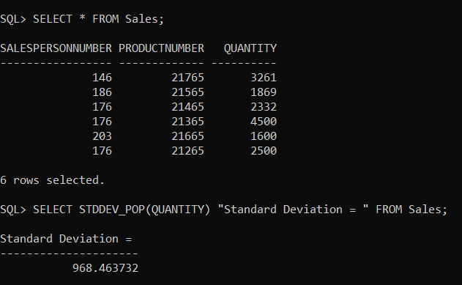

**9. var_pop(column name)**



